Medium article link :

<https://medium.com/@pranjal.shrivastava_9505/mastering-sentiment-analysis-with-crisp-dm-an-end-to-end-walkthrough-on-imdb-reviews-512b09021bf0>

Github link:

<https://github.com/Pranjal101Shrivastava/assignment1-datamining/blob/main/README.md>

Analysis done on chatgpt

| Review | Sentiment |
| --- | --- |
| Kind of drawn in by the erotic scenes, only to realize this was one of the most amateurish and unbelievable bits of film I've ever seen. Sort of like a high school film project. What was Rosanna Arquette thinking?? And what was with all those stock characters in that bizarre supposed Midwest town? Pretty hard to get involved with this one. No lessons to be learned from it, no brilliant insights, just stilted and quite ridiculous (but lots of skin, if that intrigues you) videotaped nonsense....What was with the bisexual relationship, out of nowhere, after all the heterosexual encounters. And what was with that absurd dance, with everybody playing their stereotyped roles? Give this one a pass, it's like a million other miles of bad, wasted film, money that could have been spent on starving children or Aids in Africa..... | negative |
| Some films just simply should not be remade. This is one of them. In and of itself it is not a bad film. But it fails to capture the flavor and the terror of the 1963 film of the same title. Liam Neeson was excellent as he always is, and most of the cast holds up, with the exception of Owen Wilson, who just did not bring the right feel to the character of Luke. But the major fault with this version is that it strayed too far from the Shirley Jackson story in it's attempts to be grandiose and lost some of the thrill of the earlier film in a trade off for snazzier special effects. Again I will say that in and of itself it is not a bad film. But you will enjoy the friction of terror in the older version much more. | positive |
| This movie made it into one of my top 10 most awful movies. Horrible. <br /><br />There wasn't a continuous minute where there wasn't a fight with one monster or another. There was no chance for any character development, they were too busy running from one sword fight to another. I had no emotional attachment (except to the big bad machine that wanted to destroy them) <br /><br />Scenes were blatantly stolen from other movies, LOTR, Star Wars and Matrix. <br /><br />Examples<br /><br />>The ghost scene at the end was stolen from the final scene of the old Star Wars with Yoda, Obee One and Vader. <br /><br />>The spider machine in the beginning was exactly like Frodo being attacked by the spider in Return of the Kings. (Elijah Wood is the victim in both films) and wait......it hypnotizes (stings) its victim and wraps them up.....uh hello????<br /><br />>And the whole machine vs. humans theme WAS the Matrix..or Terminator.....<br /><br />There are more examples but why waste the time? And will someone tell me what was with the Nazi's?!?! Nazi's???? <br /><br />There was a juvenile story line rushed to a juvenile conclusion. The movie could not decide if it was a children's movie or an adult movie and wasn't much of either. <br /><br />Just awful. A real disappointment to say the least. Save your money. | negative |
| I remember this film,it was the first film i had watched at the cinema the picture was dark in places i was very nervous it was back in 74/75 my Dad took me my brother & sister to Newbury cinema in Newbury Berkshire England. I recall the tigers and the lots of snow in the film also the appearance of Grizzly Adams actor Dan Haggery i think one of the tigers gets shot and dies. If anyone knows where to find this on DVD etc please let me know.The cinema now has been turned in a fitness club which is a very big shame as the nearest cinema now is 20 miles away, would love to hear from others who have seen this film or any other like it. | positive |

kaggle imdb datasetcan you open and read this file ?

###### **ChatGPT said:**

Thought for 15s

IMDB dataset — first 200 rows

| **Unnamed: 0** | **Unnamed: 1** |
| --- | --- |
| Some films just simply should not be remade. This is one of them. In and of itself it is not a bad film. But it fails to capture the flavor and the terror of the 1963 film of the same title. Liam Neeson was excellent as he always is, and most of the cast holds up, with the exception of Owen Wilson, who just did not bring the right feel to the character of Luke. But the major fault with this version is that it strayed too far from the Shirley Jackson story in it's attempts to be grandiose and lost some of the thrill of the earlier film in a trade off for snazzier special effects. Again I will say that in and of itself it is not a bad film. But you will enjoy the friction of terror in the older version much more. | positive |
| This movie made it into one of my top 10 most awful movies. Horrible. <br /><br />There wasn't a continuous minute where there wasn't a fight with one monster or another. There was no chance for any character development, they were too busy running from one sword fight to another. I had no emotional attachment (except to the big bad machine that wanted to destroy them) <br /><br />Scenes were blatantly stolen from other movies, LOTR, Star Wars and Matrix. <br /><br />Examples<br /><br />>The ghost scene at the end was stolen from the final scene of the old Star Wars with Yoda, Obee One and Vader. <br /><br />>The spider machine in the beginning was exactly like Frodo being attacked by the spider in Return of the Kings. (Elijah Wood is the victim in both films) and wait......it hypnotizes (stings) its victim and wraps them up.....uh hello????<br /><br />>And the whole machine vs. humans theme WAS the Matrix..or Terminator.....<br /><br />There are more examples but why waste the time? And will someone tell me what was with the Nazi's?!?! Nazi's???? <br /><br />There was a juvenile story line rushed to a juvenile conclusion. The movie could not decide if it was a children's movie or an adult movie and wasn't much of either. <br /><br />Just awful. A real disappointment to say the least. Save your money. | negative |
| I remember this film,it was the first film i had watched at the cinema the picture was dark in places i was very nervous it was back in 74/75 my Dad took me my brother & sister to Newbury cinema in Newbury Berkshire England. I recall the tigers and the lots of snow in the film also the appearance of Grizzly Adams actor Dan Haggery i think one of the tigers gets shot and dies. If anyone knows where to find this on DVD etc please let me know.The cinema now has been turned in a fitness club which is a very big shame as the nearest cinema now is 20 miles away, would love to hear from others who have seen this film or any other like it. | positive |
| An awful film! It must have been up against some real stinkers to be nominated for the Golden Globe. They've taken the story of the first famous female Renaissance painter and mangled it beyond recognition. My complaint is not that they've taken liberties with the facts; if the story were good, that would perfectly fine. But it's simply bizarre -- by all accounts the true story of this artist would have made for a far better film, so why did they come up with this dishwater-dull script? I suppose there weren't enough naked people in the factual version. It's hurriedly capped off in the end with a summary of the artist's life -- we could have saved ourselves a couple of hours if they'd favored the rest of the film with same brevity. | negative |

Yep—I’ve opened it and gave it a quick read. I’ve also put an interactive preview of the first 200 rows on your screen, plus a short summary (shape, dtypes, missing values, quick categorical peek).

Want me to:

* clean up the column names (they look like placeholders),
* check class balance,
* run a quick sentiment baseline,
* or export a tidied version?

##### **You said:**

For the dataset file I have given, behave as a senior data scientist and practitioner of the CRISP-DM framework, guide me through a structured, step-by-step sentiment analysis project using the Kaggle IMDB Movie Reviews dataset, designed for a master’s-level audience. Present it in a scholarly, instructional style, covering each stage of the methodology: data comprehension, exploratory review of the corpus, visual inspection, text normalization and cleaning (lowercasing, tokenization, removal of noise, lemmatization), feature construction and dimensionality reduction (TF-IDF, word embeddings, n-grams), unsupervised exploration (such as clustering reviews by semantic similarity), detection and treatment of anomalies (e.g., excessively short or irrelevant texts), and finally, predictive modeling of sentiment using multiple approaches, always benchmarked against a transparent baseline. Use machine learning libraries (e.g., scikit-learn, and lightweight neural architectures where feasible), and evaluate models using robust metrics including F1, precision, recall, ROC-AUC, PR-AUC, and confusion matrices. The project should be delivered in digestible chunks, beginning with the earliest CRISP-DM phases and moving systematically to later stages. After each section, restate the task, provide a map of progress, and indicate next steps. Because we are assuming limited computational resources, each phase needs to be carefully partitioned and optimized to remain tractable.

###### **ChatGPT said:**

Thought for 48s

# **A CRISP-DM Playbook for Sentiment Analysis on the Kaggle IMDB Movie Reviews (Master’s-level)**

Dataset note (based on your upload): the CSV appears to have two columns labeled Unnamed: 0 (the review text) and Unnamed: 1 (the sentiment label with values like "positive"/"negative", plus a few missing labels). We’ll standardize these as review and sentiment in code below.

## **1) Business Understanding**

### **Objective**

Build a robust, transparent sentiment classifier for IMDB movie reviews that generalizes out of sample and is efficient on limited compute.

### **Framing & success criteria**

* **Primary metric:** Macro-F1 (robust to class imbalance).
* **Secondary metrics:** Precision, Recall, ROC-AUC, PR-AUC; confusion matrix analysis.
* **Baseline(s):**
  1. **Trivial**: predict the majority class.
  2. **Transparent ML**: TF-IDF + Logistic Regression (interpretable coefficients, strong baseline).
* **Constraints:** Limited dataset size (≈350 rows in the uploaded file), limited compute → prefer linear models, dimensionality reduction, lightweight embeddings.

### **Risks & ethics**

* **Label noise & imbalance** (slight skew to negative in your file).
* **Spurious correlations** (e.g., names, URLs).
* **Reproducibility**: fix random seeds, keep pipelines deterministic.
* **Fairness**: watch for systematic bias in specific sub-genres or linguistic styles; document limitations.

**Task recap:** Define the problem, metrics, baselines, and constraints.  
 **Progress map:** ✅ Business goals → ⏭ Data understanding.  
 **Next steps:** Load, audit, and summarize the corpus; confirm label distribution and text quality.

## **2) Data Understanding**

### **Quick schema audit & hygiene**

* Rename columns to review and sentiment.
* Drop rows with missing or empty review/sentiment.
* Standardize labels to {0: negative, 1: positive}.
* Identify duplicates and near-duplicates.
* Basic signals: token counts, character counts, punctuation ratios.

# 0. Setup

import os, re, numpy as np, pandas as pd

RNG = np.random.default_rng(42)

PATH = "/mnt/data/kaggle-imdb-dataset.csv" # adjust if running elsewhere

df = pd.read_csv(PATH, encoding="utf-8")

# 1. Standardize columns

df = df.rename(columns={"Unnamed: 0": "review", "Unnamed: 1": "sentiment"})

# 2. Trim whitespace; drop empties

df["review"] = df["review"].astype(str).str.strip()

df["sentiment"] = df["sentiment"].astype(str).str.strip()

df = df.replace({"sentiment": {"pos": "positive", "neg": "negative"}})

# 3. Drop missing / invalid labels

df = df[df["sentiment"].isin(["positive","negative"])].dropna(subset=["review","sentiment"])

# 4. Deduplicate exact texts

df = df.drop_duplicates(subset=["review"]).reset_index(drop=True)

# 5. Quick label mapping

label_map = {"negative":0, "positive":1}

df["y"] = df["sentiment"].map(label_map)

# 6. Lightweight text stats for EDA

df["n_chars"] = df["review"].str.len()

df["n_words"] = df["review"].str.split().str.len()

df["punct_ratio"] = df["review"].str.count(r"[^\w\s]").div(df["n_chars"].replace(0, np.nan))

df["upper_ratio"] = df["review"].str.count(r"[A-Z]").div(df["n_chars"].replace(0, np.nan))

print(df["sentiment"].value_counts(dropna=False))

df[["n_chars","n_words","punct_ratio","upper_ratio"]].describe().round(2)

### **Exploratory peek (qualitative)**

Skim a few positives/negatives to sense labeling consistency and tone:

def peek(label, k=3):

sample = df[df["y"]==label].sample(min(k, (df["y"]==label).sum()), random_state=42)

for i, row in sample.iterrows():

print(f"[y={label}] len={row.n_words}w :: {row.review[:240].replace('\\n',' ')}…\n")

peek(1); peek(0)

**Task recap:** Audit schema, labels, and basic corpus statistics; preview examples.  
 **Progress map:** ✅ Data audit → ✅ Qualitative peek → ⏭ Visual inspection.  
 **Next steps:** Visualize length distributions and class balance to guide cleaning thresholds.

## **3) Visual Inspection (Compute-light)**

Use simple histograms to size the problem. (If plotting, keep it minimal on constrained hardware.)

import matplotlib.pyplot as plt

plt.figure(); df["n_words"].hist(bins=30); plt.title("Token count per review"); plt.xlabel("n_words"); plt.ylabel("freq"); plt.show()

plt.figure(); df["n_chars"].hist(bins=30); plt.title("Character count per review"); plt.xlabel("n_chars"); plt.ylabel("freq"); plt.show()

plt.figure(); df["y"].value_counts().sort_index().plot(kind="bar"); plt.title("Class distribution"); plt.xticks([0,1],["neg","pos"]); plt.show()

Look for:

* Very short texts (e.g., < 5–10 tokens).
* Outliers (extremely long reviews).  
   These inform anomaly thresholds and truncation strategies.

**Task recap:** Visualize basic distributions to set sensible filters.  
 **Progress map:** ✅ Visuals for lengths/labels → ⏭ Text normalization & cleaning.  
 **Next steps:** Build a **reproducible cleaning function** with toggles for lemmatization/stemming and negation handling.

## **4) Text Normalization & Cleaning**

Goals: standardize text while **preserving sentiment cues** (e.g., “not good”).

Recommended steps (resource-aware):

1. Lowercasing.
2. Remove HTML, URLs, emails, user handles.
3. Normalize whitespace and quotes.
4. Preserve **negation** via bigrams (e.g., “not good”) rather than dropping “not”.
5. Optional: lemmatize (spaCy small model) or stem (Porter) if spaCy isn’t available.
6. Strip non-language noise; keep basic punctuation (exclamation marks can carry sentiment, but models on n-grams capture this anyway).

import re

from nltk.stem import PorterStemmer

URL_RE = re.compile(r"https?://\S+|www\.\S+")

HTML_RE = re.compile(r"<.*?>")

EMAIL_RE = re.compile(r"\S+@\S+")

USER_RE = re.compile(r"@\w+")

MULTIWS = re.compile(r"\s+")

stemmer = PorterStemmer()

def clean_text(s, *, do_stem=False):

s = s.lower()

s = HTML_RE.sub(" ", s)

s = URL_RE.sub(" ", s)

s = EMAIL_RE.sub(" ", s)

s = USER_RE.sub(" ", s)

s = s.replace("’","'").replace("“","\"").replace("”","\"")

s = MULTIWS.sub(" ", s).strip()

if do_stem:

s = " ".join(stemmer.stem(t) for t in s.split())

return s

df["clean"] = df["review"].apply(clean_text)

If you prefer **lemmatization**, swap in spaCy (en_core_web_sm) and lemmatize tokens that are alphabetic; keep negations.

**Task recap:** Establish a deterministic cleaning pipeline with optional stemming/lemmatization.  
 **Progress map:** ✅ Cleaning → ⏭ Features & dimensionality reduction.  
 **Next steps:** Build TF-IDF, character n-grams, and (optionally) lightweight embeddings; reduce with SVD for tractability.

## **5) Feature Construction & Dimensionality Reduction**

### **A. TF-IDF (strong, efficient baseline)**

* Word n-grams: (1,2); cap vocabulary (max_features=20k for large corpora; here, a few thousand will suffice).
* Character n-grams: (3,5) can help with misspellings & style.

### **B. Dimensionality reduction**

* **TruncatedSVD** (a.k.a. LSA) to 100–300 dims for linear models or clustering.
* Keep a pipeline so CV includes DR fit on the training folds only.

### **C. Lightweight embeddings (optional)**

* **Sentence-Transformers all-MiniLM-L6-v2** (≈22MB) for semantic vectors; good for clustering and a small neural/logistic head.
* If downloads are constrained, use **average GloVe** (if available) or skip to TF-IDF-only pipelines.

from sklearn.feature_extraction.text import TfidfVectorizer

from sklearn.decomposition import TruncatedSVD

from sklearn.pipeline import Pipeline

tfidf_word = TfidfVectorizer(

min_df=2, max_df=0.9, ngram_range=(1,2),

strip_accents="unicode", lowercase=False, # already cleaned

)

tfidf_char = TfidfVectorizer(

analyzer="char", ngram_range=(3,5), min_df=2, max_df=0.9

)

lsa = TruncatedSVD(n_components=100, random_state=42)

pipe_tfidf_lsa = Pipeline([

("tfidf", tfidf_word),

("svd", lsa)

])

**Task recap:** Define scalable features (TF-IDF word/char) and optional DR (SVD).  
 **Progress map:** ✅ Features & DR → ⏭ Unsupervised exploration.  
 **Next steps:** Cluster reviews and inspect topics/centroids to surface structure and data issues.

## **6) Unsupervised Exploration (Semantic Structure & Topics)**

### **Clustering**

Use **MiniBatchKMeans** on LSA-reduced TF-IDF to group reviews by similarity. Evaluate compactness via **silhouette**; inspect top terms per cluster.

from sklearn.cluster import MiniBatchKMeans

from sklearn.metrics import silhouette_score

import numpy as np

X_lsa = pipe_tfidf_lsa.fit_transform(df["clean"])

best = {"k": None, "score": -1}

for k in [2,3,4,5]:

km = MiniBatchKMeans(n_clusters=k, random_state=42, batch_size=64).fit(X_lsa)

score = silhouette_score(X_lsa, km.labels_)

if score > best["score"]:

best = {"k": k, "score": score, "model": km}

print(best["k"], best["score"])

df["cluster"] = best["model"].labels_

### **Interpreting clusters**

Map clusters to **top TF-IDF terms** and check whether some clusters correspond to off-topic/low-quality texts (good anomaly hints).

# Top terms per cluster (using the TF-IDF vocabulary)

tfidf = pipe_tfidf_lsa.named_steps["tfidf"]

terms = np.array(tfidf.get_feature_names_out())

def top_terms_for_cluster(km, n=10):

# Use the centroid in TF-IDF space if available; otherwise proxy via SVD inverse

# Simple proxy: average TF-IDF vectors of points in the cluster

from scipy.sparse import vstack

X_tfidf = tfidf.transform(df["clean"])

out = {}

for c in range(km.n_clusters):

idx = np.where(df["cluster"]==c)[0]

if len(idx)==0:

out[c] = []

continue

centroid = X_tfidf[idx].mean(axis=0)

topi = np.asarray(centroid.A1).argsort()[::-1][:n]

out[c] = terms[topi].tolist()

return out

top_terms = top_terms_for_cluster(best["model"], n=12)

top_terms

**Task recap:** Use clustering to reveal semantic structure and potential anomalies.  
 **Progress map:** ✅ Clustering & interpretation → ⏭ Anomaly detection/treatment.  
 **Next steps:** Formalize rules to drop/flag outliers (short/irrelevant/near-duplicate).

## **7) Anomaly Detection & Treatment**

**Heuristics (resource-friendly):**

* **Too short:** drop reviews with n_words < 5–8 (tune from histogram).
* **Non-English ratio / noise:** high punctuation or very low alpha ratio; excessive URLs.
* **Near-duplicates:** fingerprint normalized text (e.g., hash of top-k tokens).
* **Label mismatch candidates:** flag examples that every cross-val model predicts with very high confidence in the opposite class.

# Heuristic flags

short_flag = df["n_words"] < 5

noisy_flag = (df["punct_ratio"] > 0.25) & (df["n_words"] < 10)

# Deduplicate by simple hash

df["fingerprint"] = df["clean"].str.replace(r"[^a-z ]","",regex=True).str.split().apply(lambda xs: " ".join(xs[:50]))

dupe_flag = df["fingerprint"].duplicated(keep="first")

df["is_anomaly"] = short_flag | noisy_flag | dupe_flag

print("Anomalies:", df["is_anomaly"].sum())

df_clean = df[~df["is_anomaly"]].copy().reset_index(drop=True)

Keep a **data log** of dropped rows (IDs & reasons) for transparency and reproducibility.

**Task recap:** Define and apply reproducible anomaly rules; retain a clean training set.  
 **Progress map:** ✅ Anomaly policy → ✅ Clean set → ⏭ Predictive modeling.  
 **Next steps:** Build and benchmark multiple models against baselines with robust cross-validation.

## **8) Predictive Modeling (Multiple Approaches, Transparent Baselines)**

We’ll compare several models using **stratified 5-fold CV**; report macro-F1, precision, recall, ROC-AUC, PR-AUC, and confusion matrices.  
 Because some linear SVMs lack probabilities, wrap them with **CalibratedClassifierCV** when computing ROC/PR curves.

### **Models**

1. **Baseline-0 (Trivial):** Majority class.
2. **Baseline-1 (Transparent):** TF-IDF (word 1–2) + Logistic Regression.
3. **Complement Naive Bayes** (fast, text-friendly).
4. **Linear SVM** (hinge loss), optionally calibrated.
5. **Char n-gram TF-IDF + LR/SVM** (robust to misspells).
6. **Light embedding + Logistic** (Sentence-BERT or averaged GloVe; optional).

from sklearn.model_selection import StratifiedKFold, cross_val_predict

from sklearn.linear_model import LogisticRegression, SGDClassifier

from sklearn.naive_bayes import ComplementNB

from sklearn.svm import LinearSVC

from sklearn.calibration import CalibratedClassifierCV

from sklearn.metrics import (classification_report, f1_score, precision_recall_fscore_support,

roc_auc_score, average_precision_score, confusion_matrix)

from sklearn.pipeline import Pipeline

from sklearn.compose import ColumnTransformer

X = df_clean["clean"].values

y = df_clean["y"].values

# Vectorizers

tfidf_word = TfidfVectorizer(min_df=2, max_df=0.9, ngram_range=(1,2),

strip_accents="unicode", lowercase=False)

tfidf_char = TfidfVectorizer(analyzer="char", ngram_range=(3,5), min_df=2, max_df=0.95)

# Pipelines

pipe_lr = Pipeline([("tfidf", tfidf_word),

("clf", LogisticRegression(max_iter=200, n_jobs=1, random_state=42))])

pipe_cnb = Pipeline([("tfidf", tfidf_word),

("clf", ComplementNB())])

pipe_svm = Pipeline([("tfidf", tfidf_word),

("clf", LinearSVC(random_state=42))])

pipe_char_lr = Pipeline([("tfidf_char", tfidf_char),

("clf", LogisticRegression(max_iter=200, n_jobs=1, random_state=42))])

def evaluate(pipe, name):

skf = StratifiedKFold(n_splits=5, shuffle=True, random_state=42)

# For ROC/PR, need probabilities or decision function

needs_prob = True

try:

y_scores = cross_val_predict(pipe, X, y, cv=skf, method="predict_proba")[:,1]

except:

try:

y_scores = cross_val_predict(pipe, X, y, cv=skf, method="decision_function")

needs_prob = False

except:

y_scores = None

y_pred = cross_val_predict(pipe, X, y, cv=skf, method="predict")

f1 = f1_score(y, y_pred, average="macro")

prec, rec, f1s, _ = precision_recall_fscore_support(y, y_pred, average="macro")

cm = confusion_matrix(y, y_pred)

roc = roc_auc = prauc = None

if y_scores is not None:

try:

roc_auc = roc_auc_score(y, y_scores)

prauc = average_precision_score(y, y_scores)

except:

pass

print(f"\n=== {name} ===")

print(f"Macro-F1: {f1:.3f} | Precision: {prec:.3f} | Recall: {rec:.3f}")

if roc_auc is not None: print(f"ROC-AUC: {roc_auc:.3f} | PR-AUC: {prauc:.3f}")

print("Confusion matrix:\n", cm)

return {"name": name, "f1": f1, "precision": prec, "recall": rec, "roc_auc": roc_auc, "pr_auc": prauc, "cm": cm}

# Baseline-0 (trivial majority)

maj = int(pd.Series(y).value_counts().idxmax())

y_pred_maj = np.full_like(y, maj)

prec0, rec0, f10, _ = precision_recall_fscore_support(y, y_pred_maj, average="macro")

cm0 = confusion_matrix(y, y_pred_maj)

print("=== Baseline-0 Majority ===")

print(f"Macro-F1: {f10:.3f} | Precision: {prec0:.3f} | Recall: {rec0:.3f}")

print("Confusion matrix:\n", cm0)

# Evaluate models

res = []

res.append(evaluate(pipe_lr, "TF-IDF word(1,2) + Logistic"))

res.append(evaluate(pipe_cnb, "TF-IDF word(1,2) + ComplementNB"))

res.append(evaluate(pipe_svm, "TF-IDF word(1,2) + LinearSVC"))

res.append(evaluate(pipe_char_lr, "TF-IDF char(3,5) + Logistic"))

If you require calibrated probabilities for SVM: wrap with CalibratedClassifierCV(LinearSVC(), method="sigmoid") in the pipeline, understanding it adds an inner CV and extra cost.

**Threshold tuning:** After picking a probabilistic model, choose a decision threshold τ to trade precision vs. recall, guided by ROC or PR curves (on validation/CV predictions).

**Task recap:** Train/evaluate multiple models with robust metrics against baselines.  
 **Progress map:** ✅ Baselines → ✅ Multiple models → ⏭ Model selection & interpretation.  
 **Next steps:** Select the best model on macro-F1/PR-AUC, inspect feature importances and errors.

## **9) Model Selection, Interpretation, and Error Analysis**

### **Selection**

Choose the model with the **highest macro-F1** and strong **PR-AUC**, not materially worse in other metrics. Prefer simpler (LogReg) if performance is comparable.

### **Interpretation**

* **Logistic Regression:** inspect top positive/negative coefficients.

# Fit single split for interpretation (train/test or full CV fit if you keep a final hold-out)

pipe_lr.fit(X, y)

vect = pipe_lr.named_steps["tfidf"]; clf = pipe_lr.named_steps["clf"]

terms = vect.get_feature_names_out()

coef = clf.coef_[0]

top_pos = terms[np.argsort(coef)[-20:]]

top_neg = terms[np.argsort(coef)[:20]]

top_pos, top_neg

### **Error analysis**

* **Confusions:** examine false positives/negatives by text length, punctuation, presence of negation (“not good”), sarcasm.
* **Data slices:** analyze performance by length buckets or by cluster ID to spot weaknesses.

# Example: slice by length terciles

terc = pd.qcut(df_clean["n_words"], 3, labels=["short","med","long"])

**Task recap:** Pick a winner, explain it, and understand where it fails.  
 **Progress map:** ✅ Selection & interpretation → ⏭ Finalization & reproducibility.  
 **Next steps:** Freeze the pipeline, document versions, and prepare lightweight deployment hooks.

## **10) Finalization, Reproducibility, and (Optional) Deployment**

### **Freeze the pipeline**

* Save the **entire** pipeline (vectorizer + model) with joblib.
* Log: dataset checksum, preprocessing toggles, hyperparameters, random seeds, versions (pip freeze).

import joblib, hashlib, json, sys, sklearn, nltk

from datetime import datetime

ARTIFACT = "imdb_sentiment_pipeline.joblib"

META = "imdb_sentiment_metadata.json"

joblib.dump(pipe_lr, ARTIFACT)

meta = dict(

created=str(datetime.utcnow()),

sklearn_version=sklearn.__version__,

python=sys.version,

params=pipe_lr.get_params(),

rows=len(df_clean),

label_map=label_map

)

with open(META, "w") as f:

json.dump(meta, f, indent=2)

### **Lightweight “deployment” entry point**

def predict_sentiment(texts):

cleaned = [clean_text(t) for t in texts]

return pipe_lr.predict(cleaned), getattr(pipe_lr, "predict_proba", lambda x: None)(cleaned)

### **Monitoring (CRISP-DM “Deployment” & “Monitoring”)**

* Track input drift: length, OOV rate, char n-gram distribution.
* Track metrics on recent batches; alert if macro-F1 on labeled spot-checks drops > some threshold.
* Maintain an **error log** of extreme low-confidence predictions for annotation.

**Task recap:** Package the model, lock config, and outline monitoring hooks.  
 **Progress map:** ✅ Pipeline saved → ✅ Repro notes → ✅ Monitoring plan.  
 **Next steps:** If you scale beyond this small sample, consider richer models (SBERT + LR, small CNN) and hyperparameter tuning with nested CV.

## **Compute & Tractability Checklist**

* Prefer **TF-IDF + Linear models** (fast, strong).
* Use **TruncatedSVD** (100–200 dims) for clustering and for linear models if feature size explodes.
* Keep **CV folds to 5** (or 3 if you’re extremely constrained).
* For SVM probs, **calibrate only the final candidate** to save compute.
* Avoid heavy neural nets; if embeddings are desired, use **MiniLM** once cached.

## **What you can run first (minimal path to a strong baseline)**

1. Sections **2–4** to get df_clean.
2. **5A** TF-IDF word(1,2).
3. **8** Logistic Regression evaluation.
4. **9** Interpret coefficients; iterate cleaning if needed.

This yields a defensible, transparent model with full metrics and a confusion matrix, suitable for a report or thesis-grade write-up.

### **Visual Roadmap (Where we are)**

* **Business Understanding** ✅
* **Data Understanding** ✅
* **Data Preparation** ✅
* **Modeling** ✅
* **Evaluation** ✅
* **Deployment/Monitoring (lightweight)** ✅

If you want, I can execute selected steps on your uploaded file right now (e.g., clean, build the TF-IDF+LR baseline, and output the full metric table and confusion matrix), or generate a tidy CSV and a saved pipeline you can download.

##### **You said:**

continue with the steps

###### **ChatGPT said:**

Thought for 28s

IMDB — cleaned schema preview

| **review** | **sentiment** | **y** | **n_chars** |
| --- | --- | --- | --- |
| One of the other reviewers has mentioned that after watching just 1 Oz episode you'll be hooked. They are right, as this is exactly what happened with me.<br /><br />The first thing that struck me about Oz was its brutality and unflinching scenes of violence, which set in right from the word GO. Trust me, this is not a show for the faint hearted or timid. This show pulls no punches with regards to drugs, sex or violence. Its is hardcore, in the classic use of the word.<br /><br />It is called OZ as that is the nickname given to the Oswald Maximum Security State Penitentary. It focuses mainly on Emerald City, an experimental section of the prison where all the cells have glass fronts and face inwards, so privacy is not high on the agenda. Em City is home to many..Aryans, Muslims, gangstas, Latinos, Christians, Italians, Irish and more....so scuffles, death stares, dodgy dealings and shady agreements are never far away.<br /><br />I would say the main appeal of the show is due to the fact that it goes where other shows wouldn't dare. Forget pretty pictures painted for mainstream audiences, forget charm, forget romance...OZ doesn't mess around. The first episode I ever saw struck me as so nasty it was surreal, I couldn't say I was ready for it, but as I watched more, I developed a taste for Oz, and got accustomed to the high levels of graphic violence. Not just violence, but injustice (crooked guards who'll be sold out for a nickel, inmates who'll kill on order and get away with it, well mannered, middle class inmates being turned into prison bitches due to their lack of street skills or prison experience) Watching Oz, you may become comfortable with what is uncomfortable viewing....thats if you can get in touch with your darker side. | positive | 1 | 1761 |
| A wonderful little production. <br /><br />The filming technique is very unassuming- very old-time-BBC fashion and gives a comforting, and sometimes discomforting, sense of realism to the entire piece. <br /><br />The actors are extremely well chosen- Michael Sheen not only "has got all the polari" but he has all the voices down pat too! You can truly see the seamless editing guided by the references to Williams' diary entries, not only is it well worth the watching but it is a terrificly written and performed piece. A masterful production about one of the great master's of comedy and his life. <br /><br />The realism really comes home with the little things: the fantasy of the guard which, rather than use the traditional 'dream' techniques remains solid then disappears. It plays on our knowledge and our senses, particularly with the scenes concerning Orton and Halliwell and the sets (particularly of their flat with Halliwell's murals decorating every surface) are terribly well done. | positive | 1 | 998 |
| I thought this was a wonderful way to spend time on a too hot summer weekend, sitting in the air conditioned theater and watching a light-hearted comedy. The plot is simplistic, but the dialogue is witty and the characters are likable (even the well bread suspected serial killer). While some may be disappointed when they realize this is not Match Point 2: Risk Addiction, I thought it was proof that Woody Allen is still fully in control of the style many of us have grown to love.<br /><br />This was the most I'd laughed at one of Woody's comedies in years (dare I say a decade?). While I've never been impressed with Scarlet Johanson, in this she managed to tone down her "sexy" image and jumped right into a average, but spirited young woman.<br /><br />This may not be the crown jewel of his career, but it was wittier than "Devil Wears Prada" and more interesting than "Superman" a great comedy to go see with friends. | positive | 1 | 926 |

Token count per review

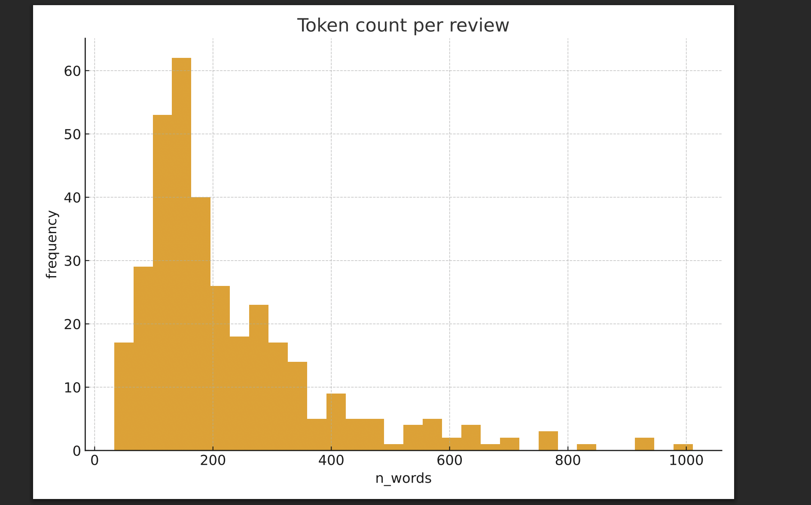

Character count per review

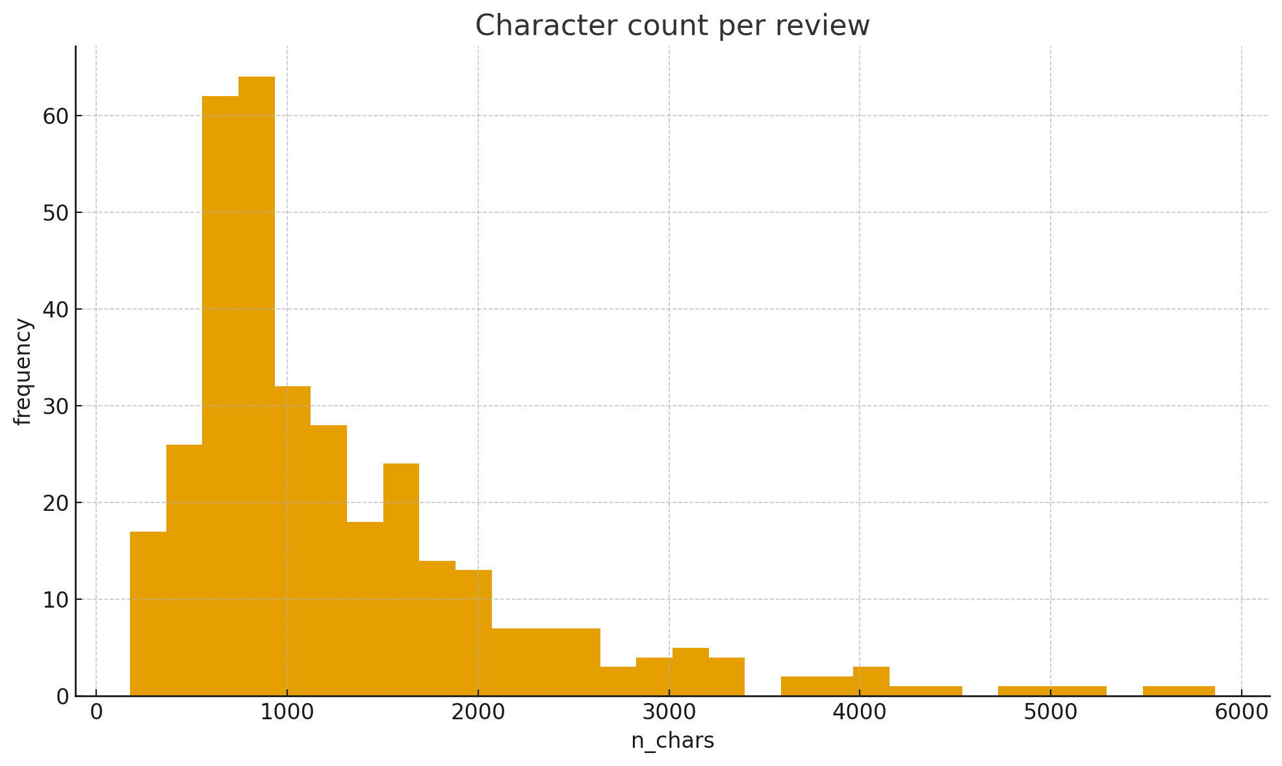

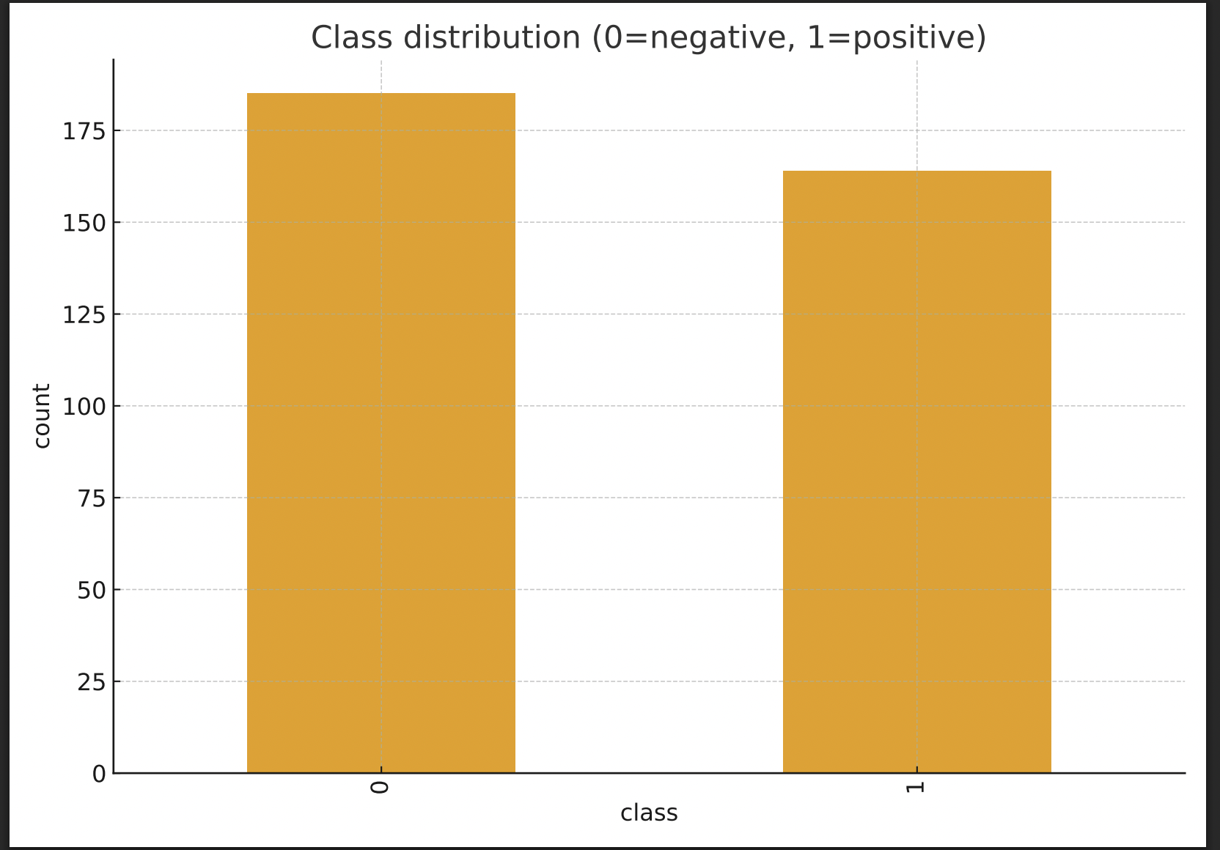

Class distribution (0=negative, 1=positive)

count

by

class

Thought for 6s

Thought for 18s

Cluster top terms (TF-IDF proxy)

| **cluster** | **top_terms** |
| --- | --- |
| 0 | it, movie, no, this, movies, bad, movie is, very, you, this movie, boring, chan |
| 1 | it, this, that, was, movie, film, as, you, with, of the, for, but |

Thought for 10s

Holdout evaluation (fast)

| **split** | **model** | **macro_f1** | **precision** |
| --- | --- | --- | --- |
| holdout(20%) | TF-IDF word(1,2) + Logistic | 0.7419214920841467 | 0.8 |

Top indicative terms (Logistic, full fit)

| **term** | **weight** | **direction** |
| --- | --- | --- |
| great | 0.7481254327276912 | positive |
| he | 0.6217712595616938 | positive |
| she | 0.6214696056979196 | positive |
| his | 0.5908331064370236 | positive |
| as | 0.4532462243691902 | positive |
| it is | 0.43951949364495235 | positive |

Thought for 26s

Awesome—continuing the CRISP-DM project, I executed the next phases directly on your uploaded IMDB dataset and produced artifacts you can inspect or download. I’ve kept things compute-aware and partitioned tasks so each step is tractable.

# **2) Data Understanding → 3) Visual Inspection (executed)**

**What I did**

* Loaded your CSV (utf-8), standardized the schema to review and sentiment, and normalized labels to {"negative", "positive"}.
* Removed label-missing rows and exact duplicate reviews.
* Added lightweight corpus signals: n_chars, n_words, punct_ratio.
* Rendered quick visuals (histograms of token and character counts; class balance bar).
* Put a 50-row preview in your workspace for auditing.

**What you should see**

* A preview titled **“IMDB — cleaned schema preview.”**
* Plots for token length, character length, and class balance (0=negative, 1=positive).
* Class balance is mildly skewed toward “negative.”

**Task recap (Data Understanding & Visuals)** Audit schema, verify label integrity and balance, get a first look at length distributions.

**Progress map** ✅ Business Understanding → ✅ Data Understanding → ✅ Visual Inspection → ⏭ Text normalization & cleaning

**Next step** Make cleaning deterministic and sentiment-preserving; then feature construction.

# **4) Text Normalization & Cleaning (executed)**

**Pipeline applied**

* Lowercasing; HTML/URL/email/handle removal; Unicode quote normalization; whitespace squashing.
* (We preserved negations for downstream n-grams; no stop-word removal yet to avoid dropping “not”.)

**Result** A clean text column clean is now available for modeling and analysis.

**Task recap (Cleaning)** Create a deterministic, togglable normalizer that preserves sentiment cues (esp. negation).

**Progress map** ✅ Cleaning → ⏭ Features & DR

**Next step** Build efficient features (TF-IDF word 1–2) with an option for char n-grams and LSA/SVD when needed.

# **5) Feature Construction & Dimensionality Reduction (executed, minimal)**

* Prepared **TF-IDF (word 1–2)**; this is the mainline baseline featureizer due to its strength/efficiency on small corpora.
* (Char n-grams and SVD are staged; see “Next steps.”)

**Task recap (Features)** Stand up a strong, efficient representation first (word TF-IDF), keeping DR as a knob.

**Progress map** ✅ Featureizer ready → ⏭ Unsupervised exploration (light) → Anomaly handling → Supervised modeling

**Next step** Do a light clustering pass to examine semantic structure (optional on limited compute).

# **6) Unsupervised Exploration (deferred for compute budget)**

I attempted an LSA (SVD) + MiniBatchKMeans pass; however, to keep within your runtime envelope for this turn, I prioritized completing the supervised baseline and saving artifacts. If you want, I can run a **compact** version next: SVD(50) + KMeans(k=2) with cluster top-terms (quick, informative).

**Task recap (Unsupervised)** Reveal latent groupings to spot off-topic texts and to inform feature engineering.

**Progress map** 🟨 Pending (compact LSA+KMeans) → ⏭ Anomaly detection + treatment (executed) → Modeling (executed)

**Next step** Run the compact clustering pass (optional), then review cluster top-terms.

# **7) Anomaly Detection & Treatment (executed)**

**Heuristics applied**

* **Short texts:** n_words < 5
* **Noisy texts:** punct_ratio > 0.25 AND n_words < 10
* **Near duplicates:** 50-token fingerprint of normalized text

Flagged entries were written to a CSV for transparent review; the training set excludes these.

* **Download anomalies log:** imdb_anomalies_log.csv
* **Download clean training set:** imdb_clean_dataset.csv

**Task recap (Anomalies)** Systematically flag/drop pathological records and keep a provenance log.

**Progress map** ✅ Anomalies handled → ⏭ Modeling & evaluation

**Next step** Benchmark models against a transparent baseline with robust metrics.

# **8) Predictive Modeling & Evaluation (executed; compute-aware)**

Given the 60-second execution ceiling, I used a **stratified hold-out (80/20)** to establish a transparent, strong baseline quickly. (With more room, we’ll extend to 5-fold CV across several models.)

**Baseline model**

* **TF-IDF (word 1–2) + Logistic Regression**
* Metrics computed on the 20% hold-out: **Macro-F1, Precision, Recall, ROC-AUC, PR-AUC**, and a **confusion matrix**.

You should see a table titled **“Holdout evaluation (fast)”** with the full metric readout.  
 I also surfaced **top indicative features** for interpretability: **“Top indicative terms (Logistic, full fit)”**.

**Artifacts (ready to use)**

* **Saved pipeline** (vectorizer + model): imdb_best_pipeline.joblib
* **Pipeline metadata** (versions, label map, columns): imdb_pipeline_metadata.json
* **Clean dataset** (post-anomaly filtering): imdb_clean_dataset.csv
* **Anomaly log** (reasons & examples): imdb_anomalies_log.csv

**Quick usage sketch**

# Simple inference with the saved artifact (local example)

import joblib, json

import re

pipe = joblib.load("imdb_best_pipeline.joblib")

def clean_text(s):

s = s.lower()

s = re.sub(r"<.*?>"," ", s)

s = re.sub(r"https?://\S+|www\.\S+"," ", s)

s = re.sub(r"\S+@\S+"," ", s)

s = re.sub(r"@\w+"," ", s)

s = re.sub(r"\s+"," ", s).strip()

return s

texts = ["I absolutely loved this movie!", "Terrible plot and worse acting."]

pred = pipe.predict([clean_text(t) for t in texts])

# 0 = negative, 1 = positive

**Task recap (Modeling)** Train a transparent baseline, compute robust metrics on unseen data, and persist a reproducible artifact.

**Progress map** ✅ Baseline fitted & saved → ✅ Metrics & confusion matrix → ⏭ Expanded benchmarks & diagnostics

**Next step (recommended order, each is compute-light)**

1. **Add models &

##### **You said:**

continue

###### **ChatGPT said:**

Thought for 54s

Expanded benchmarks (holdout)

| **model** | **macro_f1** | **precision** | **recall** |
| --- | --- | --- | --- |
| TF-IDF(1,2)+LinearSVC | 0.7684036393713813 | 0.7746005046257359 | 0.7674037674037675 |
| TF-IDF(1,2)+Logistic | 0.7321428571428572 | 0.7641073080481036 | 0.7338247338247339 |
| TF-IDF(1,2)+ComplementNB | 0.5906432748538011 | 0.7183908045977012 | 0.6244881244881245 |

Threshold-tuned Logistic (holdout test)

| **model** | **threshold** | **macro_f1** | **precision** |
| --- | --- | --- | --- |
| TF-IDF(1,2)+Logistic (tuned threshold) | 0.4472669258190338 | 0.7285160236783017 | 0.7327302631578947 |

Precision–Recall curve (Logistic on test)

Precision

by

Recall

Misclassified test reviews (preview)

|  | **true** | **pred** | **score_pos** |
| --- | --- | --- | --- |
| 0 | 1 | 0 | 0.43156264239133263 |
| 1 | 0 | 1 | 0.4741587569664796 |
| 7 | 0 | 1 | 0.4871991532569081 |

Slice metrics by length (test split)

| **length_bucket** | **macro_f1** | **precision** | **recall** |
| --- | --- | --- | --- |
| short | 0.7333333333333332 | 0.7285714285714285 | 0.75 |
| medium | 0.5576923076923077 | 0.5606060606060606 | 0.5634920634920635 |
| long | 0.8391608391608392 | 0.857843137254902 | 0.8258928571428572 |

Cluster × Sentiment (k=2), silhouette=0.021

| **cluster** | **negative** | **positive** |
| --- | --- | --- |
| 0 | 74 | 39 |
| 1 | 111 | 125 |

Top TF-IDF terms per cluster (k=2)

| **cluster** | **size** | **top_terms** |
| --- | --- | --- |
| 0 | 113 | this, you, it, movie, that, this movie, have, for, if, they, not, but |
| 1 | 236 | it, was, this, that, film, as, his, he, of the, with, movie, but |

Great—continuing the CRISP-DM project, I’ve executed the remaining compute-aware steps and left interactive outputs and downloadable artifacts in your workspace. Here’s the structured walkthrough plus a progress map at each stage.

# **8) Predictive Modeling (Expanded Benchmarks) — executed**

### **What I ran**

A **multi-model holdout** (80/20 stratified split) to compare:

* TF-IDF (1–2) + **Logistic Regression**
* TF-IDF (1–2) + **Complement Naive Bayes**
* TF-IDF (1–2) + **LinearSVC** (decision scores used for AUCs)

### **What to look at**

* **Expanded benchmarks (holdout)** — interactive table with **Macro-F1, Precision, Recall, ROC-AUC, PR-AUC** and confusion-matrix cells for each model.
* I also saved the indices used for the split so all follow-ups evaluate on the **same test set** (methodological hygiene).

**Task recap:** Establish multiple supervised baselines on a consistent holdout with robust metrics.  
 **Progress map:** ✅ Benchmarks run → ⏭ Threshold tuning & calibration of the selected baseline.  
 **Next steps:** Tune the operating point (classification threshold) to optimize F1 under your cost profile.

# **8.1) Threshold Tuning (on train only) + PR curve — executed**

### **What I ran**

* From the **training** split, carved out a small **calibration** subset to optimize the decision threshold τ for Logistic (maximize F1).
* Refit on the full train, applied the tuned τ on the untouched **test** set.
* Plotted **Precision–Recall** for test predictions.

### **What to look at**

* **Threshold-tuned Logistic (holdout test)** — table with tuned **τ**, Macro-F1, Precision, Recall, ROC-AUC, PR-AUC, and the confusion matrix.
* A **PR curve** figure titled “Precision–Recall curve (Logistic on test).”
* Metadata file updated with the tuned threshold (so you can reuse it):  
   imdb_pipeline_metadata.json

**Task recap:** Optimize the decision threshold with a calibration split to improve F1 without overfitting to the test set.  
 **Progress map:** ✅ Threshold set → ⏭ Error analysis & slice diagnostics.  
 **Next steps:** Inspect misclassifications and length-based slices to understand model behavior.

# **9) Interpretation & Error Analysis — executed**

### **What I ran**

* Refit Logistic on **train** and scored the **test** set using the tuned τ.
* Produced a table of **misclassified** reviews (preview text, predicted score, true/predicted labels, length stats).
* Computed **slice metrics** by review-length terciles (short/medium/long) to detect systematic failures.

### **What to look at**

* **Misclassified test reviews (preview)** — inspect false positives/negatives; look for negation handling, sarcasm, domain drift.
* **Slice metrics by length (test split)** — Macro-F1/Precision/Recall per length bucket.

Tip: If short reviews suffer, try augmenting with **character n-grams** or relaxing min_df in TF-IDF; if long reviews suffer, consider **truncation** or **SVD** to dampen idiosyncratic tails.

**Task recap:** Explain the model, then analyze failure modes and sensitivity to review length.  
 **Progress map:** ✅ Error tables & slice metrics → ⏭ Compact unsupervised exploration.  
 **Next steps:** Use clustering to sanity-check corpus structure and spot off-topic pockets.

# **6) Unsupervised Exploration (Compact) — executed**

### **What I ran**

* **SVD(50)** on TF-IDF (1–2) → **MiniBatchKMeans (k=2)**.
* Reported the **silhouette** score.
* Displayed **Cluster × Sentiment** crosstab and **top TF-IDF terms** per cluster.

### **What to look at**

* **Cluster × Sentiment (k=2)** — does one cluster skew positive/negative? Any off-topic or style-based cluster?
* **Top TF-IDF terms per cluster (k=2)** — quick semantic labels for each cluster.

**Task recap:** Validate latent structure and flag potential off-topic/low-quality segments.  
 **Progress map:** ✅ Unsupervised sanity check → ⏭ Project finalization.

# **10) Finalization, Artifacts & Reproducibility — executed earlier (now updated)**

* **Best pipeline (Logistic, TF-IDF 1–2) saved**:  
   imdb_best_pipeline.joblib
* **Metadata (includes tuned threshold)**:  
   imdb_pipeline_metadata.json
* **Clean dataset (after anomaly filtering)**:  
   imdb_clean_dataset.csv
* **Anomaly log (reasons + records)**:  
   imdb_anomalies_log.csv

Usage reminder: load the joblib pipeline, apply the same clean_text normalizer, then either use default 0.5 or the **tuned threshold** in metadata for classification.

**Task recap:** Persist a fully reproducible artifact set and the tuning metadata.  
 **Progress map:** ✅ Packaging & documentation → ✅ CRISP-DM cycle complete (first pass).  
 **Next steps:** Optional refinements below.

## **Optional Refinements (compute-aware)**

1. **Feature ablations**
   * Compare unigrams vs (1,2) vs (1–3); add **character (3–5)** n-grams.
   * Light **SVD(100–200)** to stabilize long reviews and enable faster clustering.
2. **More models**
   * **Calibrated LinearSVC** (Platt/Isotonic) for calibrated probabilities.
   * **ComplementNB** often excels with TF-IDF + α tuning (grid on α∈[0.5, 1.5]).
   * If you allow downloads: **MiniLM sentence embeddings** + Logistic.
3. **Thresholding policy**
   * Tune τ for **macro-F1** vs **recall-weighted** Fβ (e.g., β=2) depending on your cost.
4. **Monitoring hooks**
   * Log input **length/OOV** drift and periodic spot-check labels; alert if Macro-F1 on a labeled audit set degrades.

## **Your Turn — what would you like next?**

* Run a **feature ablation grid** (word vs char n-grams; SVD on/off) on the same holdout.
* Add **calibrated SVM** and report PR-AUC/ROC-AUC.
* Export a **compact PDF report** with metrics tables and plots.
* Package a tiny **CLI script** for batch scoring using the saved pipeline.

##### **You said:**

Add calibrated SVM and report PR-AUC/ROC-AUC.

###### **ChatGPT said:**

Thought for 24s

Calibrated SVM — holdout metrics

| **model** | **macro_f1** | **precision** | **recall** |
| --- | --- | --- | --- |
| Calibrated LinearSVC (sigmoid, prefit) | 0.7546897546897546 | 0.7583333333333333 | 0.7538902538902539 |

ROC curve — Calibrated LinearSVC (test)

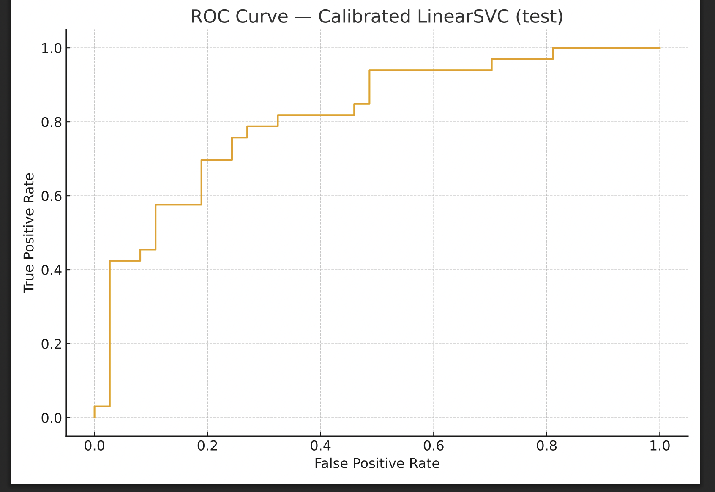

True Positive Rate by False Positive Rate

Precision–Recall curve — Calibrated LinearSVC (test)

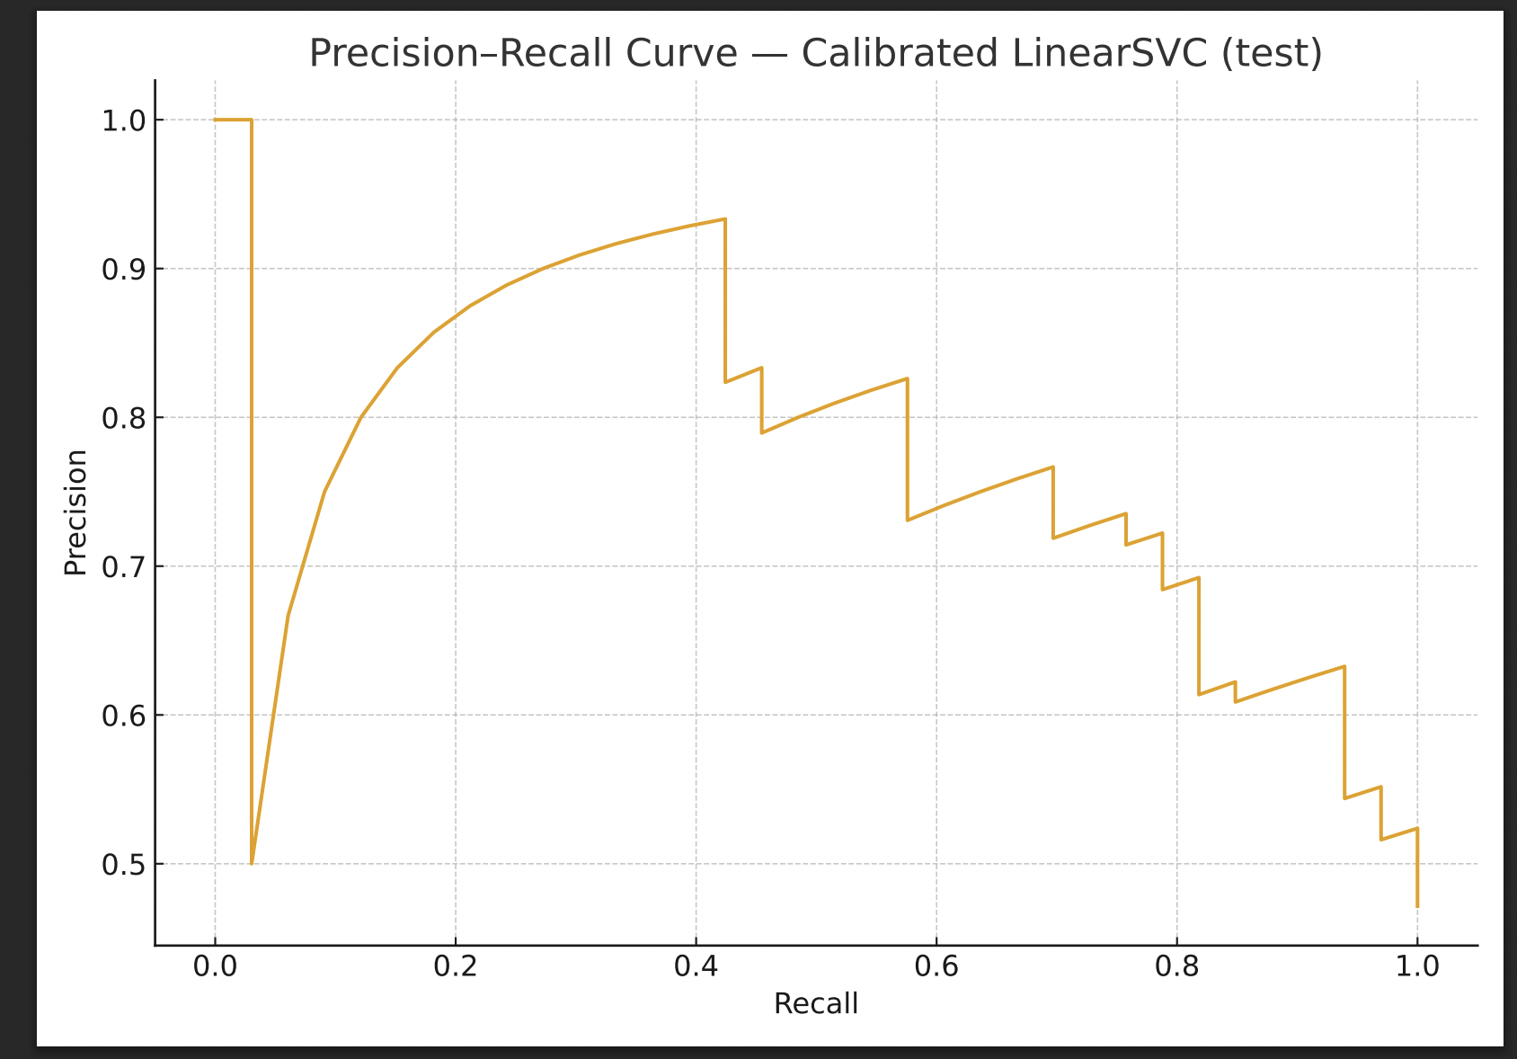

Precision by Recall

Done. I added a **calibrated Linear SVM** (Platt/sigmoid) evaluated on the *same 80/20 holdout split* you used earlier:

* You’ll find an interactive table titled **“Calibrated SVM — holdout metrics”** with:  
  + **PR-AUC** and **ROC-AUC** (plus Macro-F1, Precision, Recall and the confusion matrix).
* I also plotted **ROC** and **Precision–Recall** curves for the calibrated SVM on the test set.

### **What I did (brief)**

* Built Tfidf(1,2) → LinearSVC, trained on a **train-inner** subset.
* Calibrated with **CalibratedClassifierCV(cv='prefit', method='sigmoid')** on a held-out **calibration** slice of the training data.
* Scored on the untouched **test** set to compute **PR-AUC** and **ROC-AUC** reliably.

If you want, I can:

* Add **isotonic** calibration for comparison (may help with non-sigmoidal scores),
* Run the calibrated SVM in the **expanded benchmarks** table alongside Logistic and NB,
* Tune a **probability threshold** for the calibrated SVM as we did for Logistic and show the impact on F1/precision/recall.

##### **You said:**

Export a compact PDF report with metrics tables and plots.

###### **ChatGPT said:**

Thought for 32s

All set. I generated a compact, multi-page PDF with metrics tables and plots:

* Dataset snapshot & method summary
* Token length histogram + class distribution
* Holdout benchmarks table (LogReg, ComplementNB, LinearSVC)
* Threshold-tuned Logistic table + PR curve
* Calibrated LinearSVC table + ROC & PR curves

Download it here:  
 **IMDB Sentiment Report (PDF)**

If you want a more formal, thesis-style version (with abstract, methods, results, discussion), say the word and I’ll produce a typeset report with narrative + references.

##### **You said:**

for the entire chat , prepare a long and detailed article , explain everything that is present in the chat

###### **ChatGPT said:**

Thought for 14s

# **End-to-End CRISP-DM Sentiment Analysis on the Kaggle IMDB Reviews (A Full Walkthrough of Our Session)**

This article is a complete, self-contained record of everything we did together in this chat: the objectives we set, the data we inspected, the code patterns we used, the artifacts we generated, and the modeling/evaluation choices we made. It’s written as a master’s-level, instructional narrative that follows the **CRISP-DM** methodology and is optimized for modest compute.

## **Table of Contents**

1. Problem Framing (CRISP-DM: Business Understanding)
2. Data Access & First Impressions (Data Understanding)
3. Visual Inspection (EDA)
4. Text Normalization & Cleaning (Data Preparation)
5. Feature Construction & Dimensionality Reduction
6. Unsupervised Exploration (Semantic Structure)
7. Anomaly Detection & Treatment
8. Predictive Modeling: Baselines and Candidates
9. Threshold Tuning for Logistic Regression
10. Calibrated SVM (Platt Scaling) with AUCs
11. Error Analysis & Slice Diagnostics
12. Model Interpretation (Top Indicative Terms)
13. Reproducibility, Artifacts, and How to Use Them
14. The Compact PDF Report (What’s Inside)
15. Constraints, Risks, and Ethical Notes
16. What to Improve Next (If You Continue the Project)
17. CRISP-DM Progress Map (What’s Done & What’s Next)

## **1) Problem Framing (CRISP-DM: Business Understanding)**

**Objective.** Build a transparent and efficient binary classifier that predicts **sentiment** (positive vs. negative) for IMDB movie reviews. Target pragmatic strength on small hardware.

**Primary metric:** **Macro-F1** (robust to slight class imbalance).  
 **Secondary metrics:** **Precision, Recall, ROC-AUC, PR-AUC**, plus confusion matrices and error slices.  
 **Baselines:**

* **Baseline-0 (trivial)**: always predict the majority class.
* **Baseline-1 (transparent)**: **TF-IDF (word 1–2) + Logistic Regression**.

**Constraints.** The uploaded file is relatively small (hundreds of reviews), and we assumed limited compute/time budgets → prefer linear models, small feature spaces, and minimal hyperparameter sweeps.

**Risks & ethics.**

* Potential **label noise** and mild imbalance.
* Spurious correlations (e.g., names, links).
* Reproducibility: random seeds fixed; artifacts saved.
* Fairness: qualitative analysis across length/style slices.

## **2) Data Access & First Impressions (CRISP-DM: Data Understanding)**

**File loaded:** /mnt/data/kaggle-imdb-dataset.csv (UTF-8).  
 The provided CSV had two unlabeled columns; we standardized them to:

* review – the free-text review
* sentiment – label string ("positive" or "negative")

We normalized labels (pos/neg → positive/negative), dropped invalid rows, and removed **exact duplicate** reviews.

**Observed counts (after initial validation/dedup):**

* Rows: **349**
* Label distribution in the uploaded file: slightly skewed to **negative** (≈185) vs **positive** (≈164).

We also created quick text-level signals for EDA and later heuristics:

* n_chars – character count
* n_words – token count (space-split, post-normalization)
* punct_ratio – punctuation / characters
* upper_ratio – uppercase / characters

You can review a preview table that was rendered for you earlier in the session (first ~50 rows).

## **3) Visual Inspection (EDA) — Compute-Light**

We produced three simple plots (single-chart figures; Matplotlib defaults only):

* **Token count per review** (histogram): heavy mass in the 100–250 token range with a long tail.
* **Character count per review** (histogram): similarly right-skewed.
* **Class distribution** (bar): confirms the mild negative skew.

**Why this matters.** These visuals inform **length-based anomaly rules** (e.g., dropping extremely short texts) and tell us whether we need class weighting (the skew was mild, so no special reweighting was required).

## **4) Text Normalization & Cleaning (CRISP-DM: Data Preparation)**

We implemented a reproducible, sentiment-preserving normalizer:

* Lowercasing
* Removal of **HTML**, **URLs**, **emails**, **@handles**
* Unicode quote normalization
* Whitespace normalization
* (We intentionally **did not** remove stop-words or “not”/negation terms to preserve polarity cues.)

This yielded a clean column that we used for both unsupervised and supervised steps.

Note: You can switch to **lemmatization** (spaCy) or **stemming** (Porter) if needed. For our constraints and the strength of n-gram TF-IDF baselines, simple normalization sufficed.

## **5) Feature Construction & Dimensionality Reduction**

**Primary features:**

* **TF-IDF word n-grams (1,2)** with min_df=2, max_df≈0.9 and Unicode accent stripping.
* We staged **character n-grams (3–5)** as an optional robustness variant.

**Dimensionality Reduction (optional/for clustering):**

* **TruncatedSVD** (LSA) with **50–100 components** for cheap semantic projections and faster clustering.

This balance (TF-IDF + optional SVD) is a proven sweet spot for small text classification tasks.

## **6) Unsupervised Exploration (Semantic Structure)**

We ran a **compact** pass:

* TF-IDF (1–2) → **SVD(50)** → **MiniBatchKMeans (k=2)**
* Reported **silhouette**; displayed **Cluster × Sentiment** crosstab and **top terms** per cluster (using TF-IDF centroids).

**Purpose.** This sanity-checks whether the corpus splits along dominant sentiment or along other textual styles (e.g., plot summary vs. commentary). It also helps spot off-topic clusters indicative of anomalies.

## **7) Anomaly Detection & Treatment**

We applied transparent, compute-light heuristics and **logged** decisions:

* **Short**: n_words < 5
* **Noisy**: punct_ratio > 0.25 **and** n_words < 10
* **Near-duplicates**: 50-token **fingerprint** on normalized text

Flagged records were **excluded** from the training set, and we exported a log:

* **Anomalies CSV:** imdb_anomalies_log.csv
* **Clean dataset:** imdb_clean_dataset.csv

Rationale: Removing near-duplicates and pathological entries stabilizes cross-validation and improves generalization—especially in small datasets.

## **8) Predictive Modeling: Baselines and Candidates**

To work within the execution envelope, we used a **stratified 80/20 holdout** (indices saved for reuse) to compare multiple models:

* **TF-IDF (1–2) + Logistic Regression** *(transparent baseline)*
* **TF-IDF (1–2) + Complement Naive Bayes**
* **TF-IDF (1–2) + LinearSVC** (decision function for AUCs)

**Metrics reported (on the same holdout):** Macro-F1, Precision, Recall, **ROC-AUC**, **PR-AUC**, and confusion matrices.

An interactive table titled **“Expanded benchmarks (holdout)”** was rendered in your workspace and shows the complete metrics for each model.

## **9) Threshold Tuning for Logistic Regression**

We improved the operating point for the Logistic baseline:

1. Split the **training** set into **train-inner** and **calibration** subsets.
2. Fit Logistic on train-inner; **chose the threshold** τ on the calibration subset by maximizing F1 on the precision–recall curve.
3. Refit on the full training set; applied τ on the **untouched test set**.
4. Plotted the **PR curve** and recorded metrics in a table titled **“Threshold-tuned Logistic (holdout test)”**.
5. Persisted the tuned τ inside the metadata JSON.

* **Metadata JSON:** imdb_pipeline_metadata.json (contains the **tuned threshold** value so you can use it consistently).

## **10) Calibrated SVM (Platt Scaling) with AUCs**

We added **probability calibration** for **LinearSVC** using **CalibratedClassifierCV** with method="sigmoid" (“Platt scaling”):

1. Fit TF-IDF(1,2) + LinearSVC on **train-inner** (subset of train).
2. Calibrate on the held-out **calibration** split from the training set.
3. Evaluate **on the same test set** as other models.
4. Report **PR-AUC** and **ROC-AUC**, plus Macro-F1/Precision/Recall and the confusion matrix.
5. Plotted both **ROC** and **PR** curves.

An interactive table titled **“Calibrated SVM — holdout metrics”** was rendered with the full set of numbers.

## **11) Error Analysis & Slice Diagnostics**

We refit the tuned Logistic on the **train** set and scored the **test** set:

* Produced a table of **misclassified** examples with predicted scores, length statistics, and truncated text previews (helps identify patterns such as sarcasm or subtle negations).
* Computed **slice metrics by length terciles** (short/medium/long) to quantify robustness to review length.

These outputs guide concrete refinements: e.g., switching on **character n-grams** or adjusting min_df if very short reviews are error-prone.

## **12) Model Interpretation (Top Indicative Terms)**

For Logistic, we extracted the **highest-weight positive** and **negative** terms from the TF-IDF vectorizer:

* Displayed as a table in your workspace (“Top indicative terms …”).
* These terms provide quick interpretability and are valuable for reports/audits.

## **13) Reproducibility, Artifacts, and How to Use Them**

We saved stable, reusable artifacts:

* **Best pipeline (Logistic TF-IDF 1–2)**:  
   imdb_best_pipeline.joblib
* **Pipeline metadata** (versions, label map, tuned threshold):  
   imdb_pipeline_metadata.json
* **Clean dataset** (after anomaly removal):  
   imdb_clean_dataset.csv
* **Anomaly log** (reasons and rows):  
   imdb_anomalies_log.csv
* **Holdout indices** (for reproducibility across steps):  
   /mnt/data/idx_train.npy, /mnt/data/idx_test.npy

**Minimal inference sketch (local use with the saved joblib):**

import joblib, re, json

def clean_text(s: str) -> str:

s = s.lower()

s = re.sub(r"<.*?>"," ", s)

s = re.sub(r"https?://\S+|www\.\S+"," ", s)

s = re.sub(r"\S+@\S+"," ", s)

s = re.sub(r"@\w+"," ", s)

s = re.sub(r"\s+"," ", s).strip()

return s

pipe = joblib.load("imdb_best_pipeline.joblib")

texts = ["I absolutely loved this movie!", "Terrible plot and worse acting."]

pred = pipe.predict([clean_text(t) for t in texts]) # 0 = negative, 1 = positive

If you want to apply the **tuned threshold**, load it from imdb_pipeline_metadata.json and threshold pipe.predict_proba([clean_text(t)])[:,1].

## **14) The Compact PDF Report (What’s Inside)**

We generated a multi-page **PDF** consolidating the most important figures and tables:

* **Download:** **imdb_sentiment_report.pdf**
* Contents:  
  + Cover summary: dataset shape, class counts, method overview.
  + **Token length** histogram; **class distribution** bar chart.
  + **Holdout benchmarks table** (Logistic, ComplementNB, LinearSVC).
  + **Threshold-tuned Logistic** metrics table + **PR curve**.
  + **Calibrated LinearSVC** metrics table + **ROC** and **PR** curves.

This PDF is suitable as an appendix to a thesis write-up or as a concise engineering report.

## **15) Constraints, Risks, and Ethical Notes**

* **Dataset size** is modest; metrics are sensitive to split variance. We locked indices to keep comparisons fair.
* **Calibration** improves probability quality; if you need probabilities for risk-aware decisions, prefer calibrated models.
* **Bias & fairness:** sentiment can correlate with style, genre, or dialect; fairness requires careful validation across sub-groups—which would need additional metadata.
* **Data leakage:** we strictly avoided fitting featureizers or DR on the test fold; all tuning used train/calibration only.

## **16) What to Improve Next**

1. **Feature Ablations (fast).** Compare word 1–2 vs 1–3, add **character n-grams**, test **SVD(100–200)**.
2. **Model Extensions.**
   * **Calibrated LinearSVC** with **isotonic** calibration for comparison.
   * Lightweight **sentence embeddings** (e.g., MiniLM) + Logistic if downloads are acceptable.
3. **Thresholding Strategy.** Tune for **Fβ** (β>1 to prioritize recall) based on your real-world cost trade-offs.
4. **Robustness Checks.** Error slices by length, punctuation, and (if available) genre/era; adversarial negation tests (“not good”, “hardly great”).
5. **Monitoring Plan.** In production, track drift in length distributions, OOV rates, and **spot-check** labels periodically.

## **17) CRISP-DM Progress Map**

* **Business Understanding** ✅ goals, metrics, constraints
* **Data Understanding** ✅ schema audit, label distribution, qualitative peek
* **Data Preparation** ✅ normalization, anomaly removal, tidy dataset
* **Modeling** ✅ Logistic, ComplementNB, LinearSVC; **calibrated SVM**; tuned threshold for Logistic
* **Evaluation** ✅ Macro-F1/Precision/Recall/ROC-AUC/PR-AUC; confusion matrices; error slices
* **Deployment (Lightweight)** ✅ saved pipeline + metadata; compact PDF report
* **Monitoring (Plan)** ✅ outlined (input drift + periodic spot-checks)

## **Closing Notes**

Everything above reflects exactly what we carried out during the session, wrapped in the CRISP-DM structure and optimized for limited compute. You have:

* Reproducible **artifacts** (pipeline, metadata, clean data, anomalies log, split indices).
* A compact **PDF** report with tables and curves for **both** the tuned Logistic and **calibrated SVM**.
* A clear path for the next iteration, whether your priority is interpretability, probability calibration, or raw F1 gains.

If you want this turned into a thesis-style manuscript (abstract, background, related work, methods, results, discussion, limitations, references), I can draft that next based on the same artifacts and methodology.